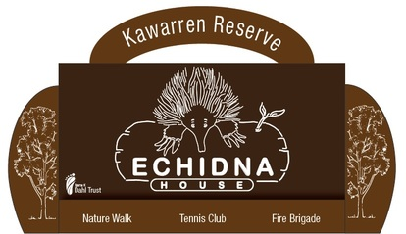
Please fill out and email kawarrenechidna@gmail.com
Major Function/Event Booking Form Application
Type of Function  please provide full details eg Wedding, Birthday party, all day seminar/workshop | Enter text.
Estimated number of attendees | Enter text.
Your Name | Enter text.
Organisation Name | Enter text.
Organisation ABN | Enter text.
Incorporated No | Enter text.
Are you? | Choose an item.
Address Required | Enter text.
Email Required | Enter text.
Phone contact Required | Enter text.
Details for Invoice to be sent/emailed | Enter text.
What facilities will you require | Choose an item.
Date of booking/s | Enter a date.
Time frame for booking (including setting up/packing up) | Enter text.
Do you require access to Echidna House/Kawarren Reserve to set up/drop off supplies/use kitchen facilities prior to the day of your booking | Choose an item.
Do you require use of the trestle tables and chairs? | Choose an item.
Is there a participation/entry fee? | Choose an item.  If yes how much $Enter text.
Food and Beverage
Will food be provided at the function? | Choose an item.
If yes – will food be sold? | Choose an item.
If yes - Have you lodged a Statement of Trade (SOT)? | Choose an item.
Will alcohol be provided? | Choose an item.
If yes – will alcohol be sold? | Choose an item.
If alcohol is to be sold during your event then a ‘Limited Licence’ must be obtained and submitted.
Catering | Choose an item.
Will the event be catered for by a Registered Catering Business? | Trading Name: Enter text.  Contact Person: Enter text.  Phone: Enter text.  Address: Enter text.
Public Liability – applicable for Weddings.  Do you have Public Liability?  If yes please provide Policy Number and Name of Insurer | Choose an item.  List your public liability details including Policy Number and Name of Insurer
Additional Information | Enter text.
Please read and complete Terms and Conditions User Agreement below

User Agreement
I have read the Terms and Conditions of Hire and agree to abide by the conditions.
I am over the age of 21 years and agree that the above information is true and correct and the booking is tentative until confirmed by Booking Officer in writing

I accept full responsibility for any damage to the Premises and/or additional fees incurred as outlined in the Terms and Conditions

Name: Enter your name
By ticking this box I confirm that I am the person named above and that I authorise the use of a digital tick box in place of my paper based signature.
Date: Enter a date.
Please ensure all applicable sections are complete, failure to do so will result in your booking being declined.
Please send all documentation to: kawarrenechidna@gmail.com
If you require further information regarding bookings please contact Booking Officer: 0412 171 640

